**Project Identification**

|  |  |
| --- | --- |
| **Project:** | Cross Campus |
| **Prepared By:** | XCampus |
| **Document Version:** | 0.1 |
| **Published Date:** | Tuesday, October 4th, 2016 |

**Contributors**

| **Name** | **Title** |
| --- | --- |
| Karim Boucher | *Owner/Developer* |
| Pavle Boraniev | *Owner/Lead Developer* |
| Mark Gallant-Wheeler | *Owner/Developer* |
| Kazuma Sato | *Owner/Developer* |

**Distribution**

| **Name** | **Title** |
| --- | --- |
| Anjana Shah | Program Coordinator |
|  |  |

**Referenced Documents**

|  |  |  |  |  |
| --- | --- | --- | --- | --- |
| **Version number** | **Title** | **Author** | **Date** | **Source / Location** |
| 1.0 | Helping Old People Easily (HOPE) Project Vision Document. | Team Obiwan | 11/30/10 | <https://www.utdallas.edu/~chung/RE/Presentations10F/Team-hope/1%20-%20VisionDoc.pdf> |
|  |  |  |  |  |
|  |  |  |  |  |

**Revision History**

|  |  |  |  |
| --- | --- | --- | --- |
| **Version Number** | **Revision Date** | **Summary of Changes** | **Modified by** |
| 0.1 | *03/10/2016* | Initial Draft | Karim Boucher |
| 0.2 | *05/10/2016* | Added diagram, minor changes | Mark Wheeler |
|  |  |  |  |

TABLE OF CONTENTS

1. Business Context Diagram 3

2. REquirements Scope Statements 4

3. High Level Business Requirements (HLR) Traceability 4

4. High Level Business Requirements Sign-Off 5

1. Business Context Diagram

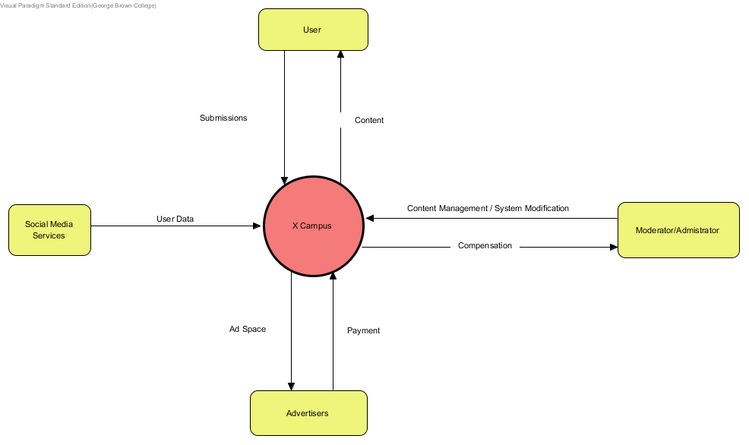

|  |  |
| --- | --- |
| **Requirement Scope Area** | **Description** |
| XCampus | A system through which students can access, and share class notes. Maintained service for offering tutoring services. Marketplace for students in both upper and lower years to buy, trade and sell textbooks. |

|  |  |
| --- | --- |
| **External Entity** | **Description** |
| User | Registered or Non-Registered User. Viewing, posting and editing privileges based on registration state. |
| Moderator | Registered user who can flag content, and suspend other users. |
| Administrator | System technician. Performs system modification. |
| Advertisers | Revenue stream. Pays money to post advertisements. |
| Social Media Services | Service users can use to share content and generate user data for ease of registration |

| **Information Flows** | **Description** |
| --- | --- |
| View Content | Non-Registered and Registered Users can view posted content |
| Post/Manage Own Posted Content | Registered User can manage submitted content |
| Content Management | Screening Content put up by Registered Users |
| System Modification | Admins can perform system alterations of any kind |
| Post advertisements | Advertisers fill allocated space with ad content |

1. Requirements Scope Statements

|  |  |  |
| --- | --- | --- |
| **HLR#** | **Description** | **Priority** |
|  | User shall be able to upload notes | High |
|  | User shall be able to download notes | High |
|  | User shall be able to access tutoring for a desired course | High |
| HLR04 | User shall be able to provide tutoring for a desired course | High |
| HLR05 | User shall be able to advertise available textbooks | High |
| HLR06 | User shall be able to view textbook advertisements | High |

1. High Level Business Requirements Sign-Off

The undersigned acknowledge their agreement with the contents of Version 0.1 of the High-Level Requirements document for Cross Campus.

Following approval of this document, requirements changes will be governed by the project’s change management process, including impact analysis and appropriate reviews and approvals, under the general control of the Project Plan and according to company policy. Approved Change Request Documents, if present, will be attached to this Requirements Document as updates.

|  |  |  |
| --- | --- | --- |
| **Name** | **Project Role and**  **Functional Area** | **Date Signed** |
| Mark Gallant-Wheeler | *Owner/Developer* | October, 4th 2016 |
| Pavle Boraniev | *Owner/Lead Developer* | October, 4th 2016 |
| Karim Boucher | *Owner/Developer* | October, 4th 2016 |
| Kazuma Sato | *Owner/Developer* | October, 4th 2016 |

* Note: physical signatures are not required. Email approvals are acceptable and should be appended to project documents.